SF.SmokeTestScripts_TC_SF_OBRequiredFieldsOnSalesStage_Instance1_12-Apr-2017_02-14-08_PM_Invoke_Application.png



SF.SmokeTestScripts_TC_SF_OBRequiredFieldsOnSalesStage_Instance1_12-Apr-2017_02-14-16_PM_Login.png

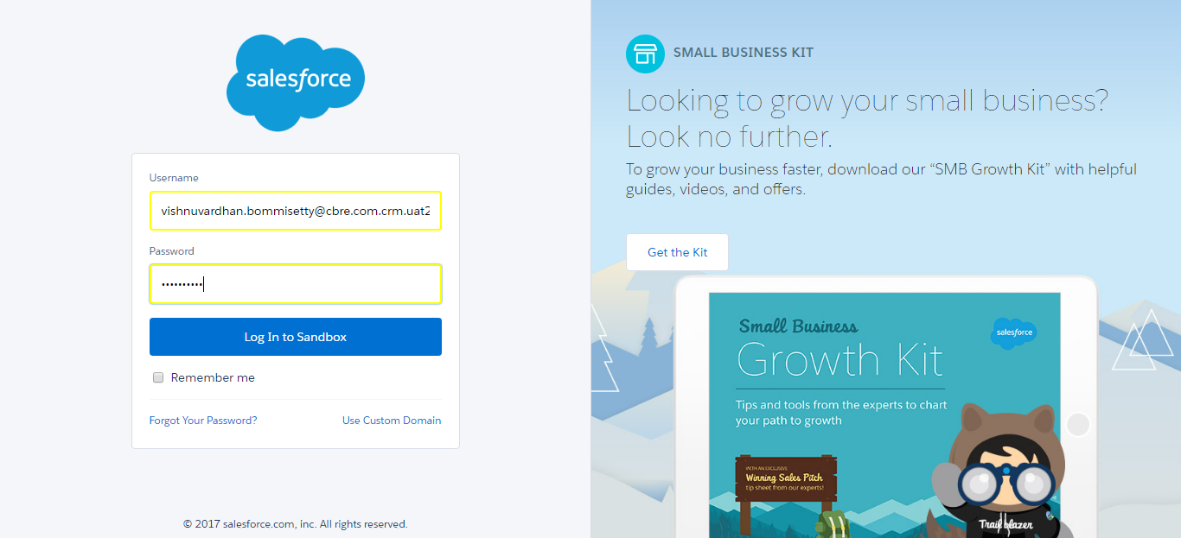

SF.SmokeTestScripts_TC_SF_OBRequiredFieldsOnSalesStage_Instance1_12-Apr-2017_02-14-26_PM_Verify_Login.png

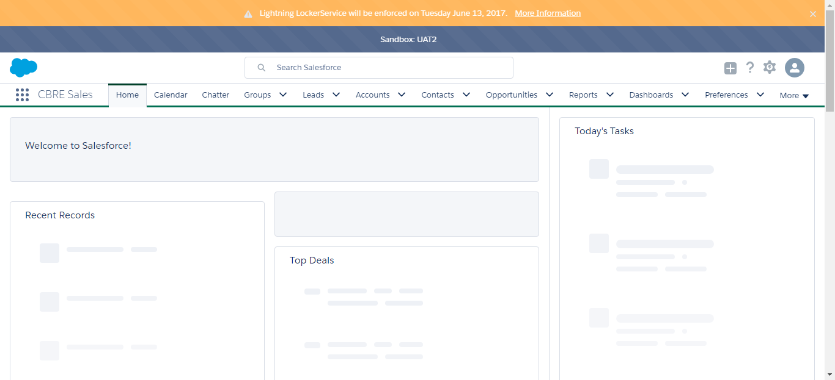

SF.SmokeTestScripts_TC_SF_OBRequiredFieldsOnSalesStage_Instance1_12-Apr-2017_02-14-28_PM_Verify_Fetch_Record.png

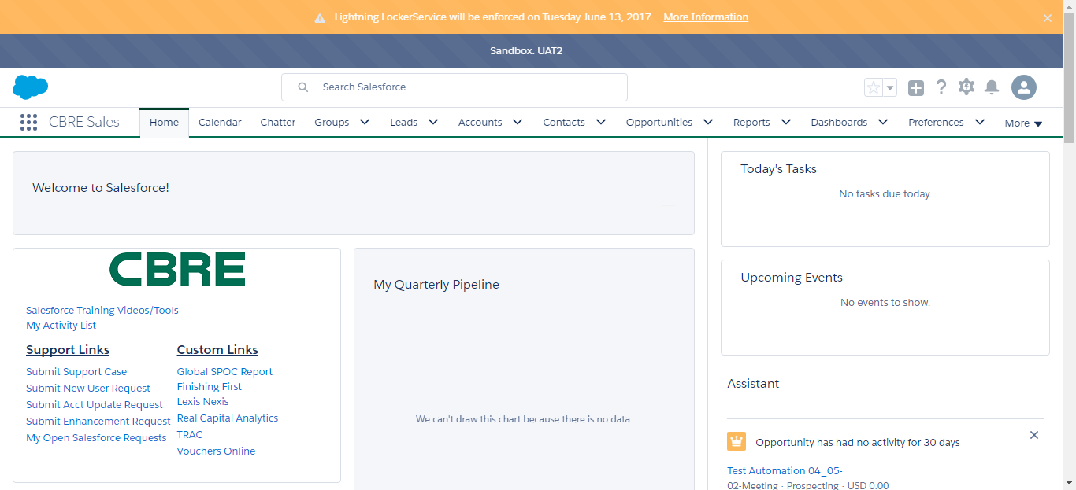

SF.SmokeTestScripts_TC_SF_OBRequiredFieldsOnSalesStage_Instance1_12-Apr-2017_02-14-31_PM_Verify_Add_Opportunity_Page



SF.SmokeTestScripts_TC_SF_OBRequiredFieldsOnSalesStage_Instance1_12-Apr-2017_02-14-31_PM_Verify_Opportunity_Required



SF.SmokeTestScripts_TC_SF_OBRequiredFieldsOnSalesStage_Instance1_12-Apr-2017_02-15-07_PM_Error.png

